**Electronics Product Management Application**

### Document Properties

| Item | Details |
| --- | --- |
| Document | Architecture Design Document |
| Application | Electronics Product Management Application |
| Author | Pranati Ghorpade |
| Version | V1.0 |
| Creation Date | 07/09/2020 |
| Last Updated | 07/09/2020 |
| Status | Completed |

Contents

Document Properties 1

**1.** **Introduction** 3

**2.** **Use-Case View** 3

**3.** **Flow Chart** 4

**4.** **Components** 4

**5.** **Services** 5

**6.** **Validations** 5

**7.** **Tools and Libraries** 5

**8.** **Unit Testing** 5

**9.** **Responsive** 6

**10.** **Accessibility** 6

**11.** **Open Items** 7

**12.** **Setup** 7

# **Introduction**

This document provides a comprehensive architectural overview of the application, using number of different architectural views to depict different aspects of the application.

# **Use-Case View**

The application use cases are –

If user is authenticated then following features will be accessible to user else only login, signup and View product list will be accessible to user.

* **Login** – It provides the functionality to login the application and giving user access to add, edit and delete the product.
* **Sign UP:** It provides the functionality to register the user for accessing application.
* **View Product List** – It provide functionality to view all the products present in the list.

* **Add Product to the List** – It provides the functionality to add the new product in the list.
* **Edit Product Details –**It provides the functionality to edit the exiting product the details and update it.
* **Delete Product** – It provides the functionality to delete the product from the list

These use cases are initiated by the user.

# **Flow Chart**

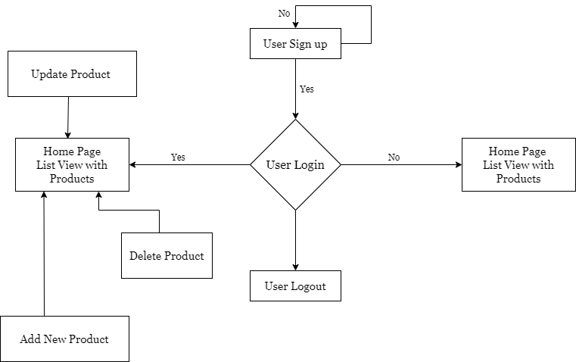

# **Components**

1. AppComponent – This component is used for Application Bootstrapping
2. HeaderComponent – This component is used as header of the application.
3. LoginSignupComponent- This allows user to logging and register the application and provides the access to the add, delete and update product features.
4. ProductListComponent – This component is served as the home page of the application. All the products are listed here.
5. ProductCreateEditComponent– This component contain form for add and edit product details.

# **Services**

There are three services –

1. AuthService – This service is having logic of user login and signup.
2. ProductService – This service generally having logic about product in the application and this contain code for getting product, edit product details, add new product and delete product logic.
3. ThemeService – This service is having logic to toggle the theme either light or dark mode.

# **Validations**

1. Application covered the required validation for Login, Signup and product fields.
2. Reactive form for validation.
3. Required attribute true for required form element.

# **Tools and Libraries**

1. Angular version: 10.0.5
2. TypesScript: 3.9.5
3. Rxjs: 6.5.5
4. jest: 26.4.2
5. ngrx store: 8.5.0
6. rxjs: 6.5.5
7. protractor: 7.0.0
8. ts-node: 8.3.0
9. tslint: 6.1.0
10. typescript: 3.9.5

# **Unit Testing**

Added Unit Test cases for services.

It consists of two services -

1. Product.service.ts – It contain test cases for the all the logic like add product, update product, delete product and get product.
   * + No of test cases: 6
2. Other files related test cases
   * + No of test cases: 17

**Total test cases passed: 23**

**Screenshot for unit test cases -**

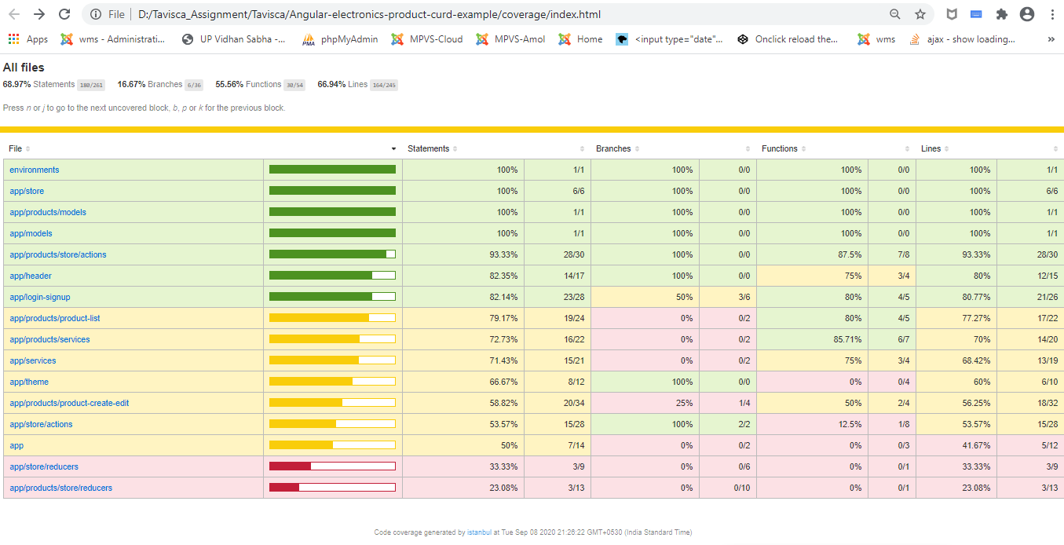

# **Responsive**

1. The application is responsive with all the device and desktop size.
2. Used grid css for templating.

# **Accessibility**

For Accessibility, application having appropriate HTML tags that are preferred for accessibility

User can run application via keyboard and tab.

# **Open Items**

1. Storybook

# **Setup**

1. Download and install node.js (version: 12.16)
2. Install npm and install @angular (version: 10.0)
3. Git clone <https://github.com/pranatighorpade/Angular-electronics-product-curd-example> origin master
4. Navigate to cloned folder & run npm install
5. Run ng serve
6. For testing use

ng test

Test Username: [tavisca@gmail.com](mailto:tavisca@gmail.com)

Password: Tavisca@123